CHAPTER 1
INTRODUCTION

1.1 Project Description
Over the past decade, Artificial Intelligence (AI) and Natural Language Processing (NLP) have reshaped how users interact with information systems in meaningful ways [15]. Research institutions and knowledge-intensive organisations, in particular, generate and consume substantial volumes of scholarly information spanning thousands of publications annually. Despite this wealth of available data, researchers frequently struggle to retrieve, synthesise, and cite accurate evidence in a timely manner, largely because they must depend on manual search processes or traditional keyword-based retrieval tools. Rule-based and keyword-driven search systems deployed in academic workflows tend to return ranked lists of papers that are often contextually mismatched with the actual intent behind a user's query [23].
To address these limitations, the proposed project titled "Multi-Agent Retrieval Augmented Generation System for Academic Research Automation" focuses on building an intelligent pipeline that genuinely understands user intent and produces contextually grounded, evidence-backed research reports. The system draws on Large Language Models (LLMs) alongside Retrieval-Augmented Generation (RAG) [1] to improve response accuracy by first retrieving relevant passages from scholarly documents before the generation step. This retrieval-before-generation approach enables the system to deliver more reliable and semantically coherent answers compared to purely parametric, rule-based systems.
The proposed system incorporates a multi-agent architecture consisting of nine specialized agents: QueryAgent, QueryExpansionAgent, RetrievalAgent, RelevanceVerifierAgent, AcquisitionAgent, RetrieverAgent, CompressionAgent, EvidenceExtractorAgent, and ReasoningAgent. The QueryAgent is responsible for analyzing user queries and detecting their intent and focus terms. Subsequent agents handle query expansion, hybrid retrieval from OpenAlex and CORE APIs [2][3], relevance filtering, PDF acquisition, text extraction, semantic chunking, vector-based retrieval using FAISS, evidence structuring, and final report synthesis using a locally hosted LLM.
The system is built on FastAPI as the backend framework and React.js with Vite and Tailwind CSS for the frontend user interface. Institutional and scholarly documents retrieved from open-access APIs are processed using text extraction and chunking techniques. The extracted text is converted into vector embeddings using a Sentence Transformer model [7] and stored in the FAISS vector database [2][3] to enable semantic search and efficient retrieval. LangChain is utilized for orchestration of the retrieval pipeline and interaction with the LLM [1].
The primary objective of the project is to reduce the time and effort required to access and synthesise academic information while improving the accuracy and relevance of research assistance. The system aims to provide accurate, context-aware, and citation-grounded research reports for students, researchers, and knowledge workers within academic and enterprise environments.

1.2 Company Profile
This project was developed as part of the Master of Computer Applications (MCA) curriculum under the Department of MCA, RV College of Engineering, Bengaluru. RV College of Engineering is one of the premier autonomous engineering institutions affiliated with Visvesvaraya Technological University (VTU), Belagavi. The institution is known for promoting innovation, technical excellence, and research-oriented learning among students.
The Department of MCA provides students with strong foundations in software development, artificial intelligence, data science, cloud computing, and emerging technologies. The department encourages students to work on real-world problems through project-based learning and research activities. This project was undertaken with the objective of applying modern AI technologies such as Large Language Models, Retrieval-Augmented Generation, multi-agent architectures, and semantic search techniques to solve practical problems in academic research automation.
The project reflects the institution's emphasis on innovation-driven education and the application of advanced technologies to improve user experience and system efficiency in research and knowledge management environments.

1.3 Dissertation Organization
The dissertation is organized into multiple chapters to provide a structured explanation of the project development process and implementation details.
- Chapter 1 – Introduction: Presents the project overview, objectives, motivation, company profile, and organization of the dissertation.
- Chapter 2 – Literature Review: Discusses existing research works, literature survey, existing and proposed systems, tools, technologies, and system requirements.
- Chapter 3 – Software Requirement Specifications: Describes functional requirements, non-functional requirements, external interface requirements, and design constraints of the proposed system.
- Chapter 4 – System Design: Explains the architectural design, system perspective, and context diagram of the The system system.
- Chapter 5 – Detailed Design: Includes UML diagrams such as class diagram, use case diagram, sequence diagram, activity diagram, data flow diagrams, database design, and module-level design details.
- Chapter 6 – Implementation: Describes the implementation process, technologies used, and important code snippets related to the project.
- Chapter 7 – Software Testing: Covers testing methodologies, test cases, validation procedures, and performance evaluation of the system.
- Chapter 8 – Conclusion: Summarizes the outcomes and achievements of the project.
- Chapter 9 – Future Enhancements: Discusses possible improvements and future extensions that can enhance the functionality and performance of the system.
- Bibliography: Contains references to journals, research papers, books, and online resources used during the project development process.

CHAPTER 2
LITERATURE REVIEW

2.1 Literature Survey
The continued advancement of Artificial Intelligence (AI), Natural Language Processing (NLP), and Large Language Models (LLMs) has had a notable impact on the development of intelligent research assistance systems across many domains [15][16]. As academic institutions and research organisations manage ever-growing volumes of scholarly literature, there is a growing expectation that information retrieval tools should deliver accurate, context-sensitive responses rather than generic text matches. Traditional retrieval systems and rule-based approaches frequently fall short of this expectation because they process queries at a syntactic level and are unable to capture semantic meaning [23].
Several researchers have explored automated research assistance systems as a way to reduce the manual burden of literature review and evidence synthesis. Early systems in this space relied heavily on keyword-matching approaches, where a fixed set of manually authored patterns triggered corresponding predefined responses. While straightforward to implement, such systems proved brittle in practice: they lacked the contextual flexibility needed to handle queries phrased in unfamiliar ways or queries that required any degree of reasoning across multiple documents [17].
Recent progress in transformer-based Large Language Models, especially GPT-family architectures [6], has substantially raised the bar for intelligent systems by enabling richer language understanding and more fluent response generation [4][5]. However, a well-known limitation of standalone LLMs is their tendency to produce hallucinated or factually incorrect statements when queried about domain-specific knowledge not captured in their parameters [6]. Retrieval-Augmented Generation (RAG) was proposed precisely to address this shortcoming: it combines retrieval mechanisms with generative models so that relevant passages are fetched from external knowledge sources before a response is composed, leading to outputs that are both more accurate and more grounded in verifiable information [1].
Semantic search has emerged as a critical component in modern information retrieval, offering a clear advantage over keyword-based methods by matching queries based on meaning rather than lexical overlap [17][24]. Vector databases such as FAISS enable high-speed similarity search over dense embedding spaces and have been widely adopted for storing and querying text embeddings at scale [2][3]. Unlike bag-of-words or TF-IDF approaches [23], semantic search identifies contextually relevant information based on underlying meaning rather than exact keyword matching, making it particularly effective for handling the natural-language variability inherent in research queries [7][8].
Multi-agent architectures have attracted growing interest in intelligent system design because they allow complex tasks to be broken down and assigned to specialized agents rather than handled by a monolithic component [15]. Systems structured this way tend to be more modular, scalable, and easier to reason about, since each agent can be developed, tested, and improved independently. In research assistance applications, this decomposition is particularly beneficial: separate agents can manage query routing, document retrieval, evidence extraction, and synthesis, reducing the cognitive load placed on any single module and improving overall accuracy [16].
Taken together, the evidence from recent literature suggests that combining LLMs, semantic retrieval, vector databases, and multi-agent coordination can meaningfully improve the reliability, accuracy, and user experience of intelligent research assistance applications [1][4][9]. Building on these findings, the proposed project designs The system, which integrates LLMs with RAG and a nine-agent multi-agent architecture to deliver efficient and context-aware automated research assistance.

2.2 Existing and Proposed System
Existing System
Traditional research assistance systems primarily depend on academic search engines, manual literature review workflows, static databases, or keyword-based retrieval tools for information dissemination. These systems often require researchers to manually search through multiple sources, read dozens of papers, and synthesize evidence independently. Existing chatbot and QA systems generally rely on predefined rules and fixed response patterns, limiting their ability to understand natural language research queries.
In many cases, keyword-based systems fail to provide accurate responses when user queries are phrased differently or contain contextual variations. Additionally, traditional systems are not capable of performing semantic understanding or retrieving information from dynamically accessed academic document repositories. As a result, researchers may experience delays, irrelevant responses, or incomplete information retrieval.
Some AI-based systems utilize Large Language Models for conversational interaction. However, standalone LLM-based systems may generate responses without verifying scholarly data, resulting in hallucinated or inaccurate outputs. Most existing systems also lack modularity and intelligent query routing mechanisms.
Limitations of Existing System
- Limited contextual understanding of research queries
- Dependency on predefined rules and keyword matching
- Inability to retrieve information from live academic document repositories dynamically
- Higher probability of hallucinated or inaccurate responses from standalone LLMs
- Lack of end-to-end semantic search and evidence extraction capability
- No intelligent multi-agent query routing mechanism
- Limited scalability and flexibility for diverse research query types
Proposed System
The proposed system aims to develop The system, an Intelligent Multi-Agent System for Automated Research Assistance using Large Language Models and Retrieval-Augmented Generation. The system is designed to provide accurate, context-aware, and citation-grounded research reports to academic researchers by retrieving relevant information from open-access scholarly databases.
The system incorporates a multi-agent architecture consisting of:
- QueryAgent – detects query intent and focus terms
- QueryExpansionAgent – generates expanded search terms
- RetrievalAgent – fetches papers from OpenAlex and CORE APIs
- RelevanceVerifierAgent – filters weakly relevant papers
- AcquisitionAgent – downloads PDFs and extracts full text
- RetrieverAgent – builds FAISS index and retrieves relevant chunks
- CompressionAgent – compresses and deduplicates retrieved chunks
- EvidenceExtractorAgent – builds structured evidence objects
- ReasoningAgent – generates final report using the Ollama LLM
The proposed system uses Retrieval-Augmented Generation (RAG), where document embeddings are generated from acquired PDF text and stored in FAISS for efficient semantic retrieval. Retrieved context is then passed to the Large Language Model to generate a meaningful, citation-normalized research report. The system exposes a FastAPI backend and a React/Vite/Tailwind CSS frontend for user interaction.
Advantages of Proposed System
- Provides context-aware and semantically relevant research reports with inline citations
- Supports dynamic retrieval from live academic databases (OpenAlex, CORE, Unpaywall)
- Improves response accuracy using the RAG architecture
- Enables efficient semantic search using FAISS with sentence-transformer embeddings
- Supports modular nine-agent multi-agent architecture
- Reduces manual effort in literature review and evidence synthesis
- Runs entirely locally without dependency on paid cloud LLM APIs

2.3 Tools and Technologies Used
TABLE 2.3.1 : Tools and Technologies Used
Sl. No. | Tool / Technology | Purpose
1 | Python 3.10 | Primary programming language for backend development and AI integration
2 | FastAPI + Uvicorn | Used to develop backend REST APIs and handle server-side operations
3 | React.js + Vite | Used for developing the frontend user interface with fast build tooling
4 | Tailwind CSS | Used for designing responsive and modern UI components
5 | LangChain | Used for orchestrating the Retrieval-Augmented Generation (RAG) pipeline and LLM interaction
6 | Ollama (qwen2.5:7b) | Local LLM backend used for generating research report responses
7 | FAISS (Facebook AI Similarity Search) | Used as a vector database for semantic similarity search and retrieval
8 | Sentence Transformers (all-MiniLM-L6-v2) | Used for generating vector embeddings from document chunks
9 | CrossEncoder (ms-marco-MiniLM-L-6-v2) | Used for re-ranking retrieved document chunks by relevance
10 | PyMuPDF (fitz) | Used for extracting text from downloaded PDF documents
11 | OpenAlex API | Primary open-access academic paper retrieval source
12 | CORE API | Secondary academic paper retrieval source requiring API key
13 | Unpaywall API | Fallback source for open-access PDF acquisition via DOI
14 | python-dotenv | Used for managing environment variables and API keys securely
15 | Visual Studio Code | Used as the integrated development environment (IDE)

2.4 Hardware and Software Requirements
Hardware Requirements:
TABLE 2.4.1 : Hardware Requirements
Component | Minimum Requirement | Recommended Requirement
Processor | Intel Core i5 (x86-64) | Intel Core i7 or AMD Ryzen 7 (8+ cores)
RAM | 8 GB | 16 GB (for running Ollama alongside pipeline)
Storage | 10 GB free (SSD preferred) | 50 GB SSD
Internet Connectivity | Broadband Connection | High-Speed Internet for API access
GPU | Not required | Optional – for faster embedding generation

Software Requirements:
TABLE 2.4.2 : Software Requirements
Software | Specification
Operating System | Ubuntu 22.04 LTS / Windows 10 with WSL2 / macOS
Programming Language | Python 3.10 or higher
Backend Framework | FastAPI + Uvicorn
Frontend Framework | React.js + Vite
AI Framework | LangChain, LangChain-Community, LangChain-HuggingFace
Vector Database | FAISS-CPU
Embedding Model | sentence-transformers/all-MiniLM-L6-v2
LLM Runtime | Ollama with qwen2.5:7b model
PDF Processing | PyMuPDF (fitz)
Development Tools | VS Code, Node.js v18+
Browser | Google Chrome 120+ / Firefox 120+

System Limitations
- Requires internet connectivity for OpenAlex, CORE, and Unpaywall API access
- Response quality depends on quality and availability of open-access PDF documents
- Performance may vary based on hardware configuration
- Local Ollama LLM requires sufficient RAM and storage for model weights

CHAPTER 3
SOFTWARE REQUIREMENT SPECIFICATIONS

3.1 Introduction
Software Requirement Specification (SRS) is a formal document that describes the functional and non-functional requirements of a software system in a structured manner. It serves as a foundation for system design, implementation, testing, and maintenance activities. The SRS document helps developers, testers, and users clearly understand the expected behavior, functionalities, constraints, and performance requirements of the proposed system. It also acts as a communication medium between stakeholders and developers during the software development lifecycle.
The proposed project, "Multi-Agent Retrieval Augmented Generation System for Academic Research Automation," is designed to provide an intelligent and automated platform for transforming natural language research queries into evidence-grounded technical reports. The system enables researchers and students to interact with the pipeline through natural language queries and receive context-aware, citation-normalized reports generated using modern Artificial Intelligence technologies. The system reduces dependency on manual literature search and synthesis by automating information retrieval related to academic publications, research papers, and scholarly evidence.
Traditional information systems and research search tools generally rely on keyword matching and ranked retrieval, which often produce incomplete or irrelevant answers whenever users phrase queries in unexpected ways. To overcome these limitations, the proposed system incorporates Retrieval-Augmented Generation (RAG) [1], semantic search techniques [7][8], and a multi-agent architecture. The RAG mechanism improves response generation by first retrieving relevant contextual passages from acquired scholarly documents before passing that context to a Large Language Model (LLM) for final report formulation.
The system consists of nine intelligent agents including the QueryAgent, QueryExpansionAgent, RetrievalAgent, RelevanceVerifierAgent, AcquisitionAgent, RetrieverAgent, CompressionAgent, EvidenceExtractorAgent, and ReasoningAgent. These agents collectively perform query understanding, paper retrieval, document acquisition, semantic indexing, evidence extraction, and report synthesis. This chapter describes the software requirements of the proposed system, including system functionalities, interface requirements, design constraints, and performance expectations.

3.2 General Description
The proposed system, "Multi-Agent Retrieval Augmented Generation System for Academic Research Automation," is designed to provide an intelligent and modular platform for automated academic research assistance. The system enables researchers and students to interact with the pipeline through natural language queries and receive citation-grounded research reports. The system aims to simplify the process of retrieving and synthesizing information related to academic topics, technical comparisons, survey requests, and factual research questions.
The system uses Large Language Models (LLMs) [6] together with Retrieval-Augmented Generation (RAG) [1] to provide context-aware and semantically relevant responses. Rather than relying solely on parametric LLM knowledge, the system retrieves relevant passages from acquired scholarly documents and uses that retrieved context to guide report generation. This design choice improves the accuracy, relevance, and adaptability of the generated reports compared to conventional retrieval or purely generative systems [4][5].
The proposed system follows a nine-agent multi-agent architecture where specialized agents perform different tasks within the research assistance pipeline. The system consists of the following functional modules:
- Query Analysis Module
- Query Expansion Module
- Hybrid Retrieval Module
- Relevance Verification Module
- Document Acquisition and Text Extraction Module
- Vector Embedding and FAISS Indexing Module
- Semantic Retrieval and Reranking Module
- Evidence Extraction Module
- LLM Report Synthesis Module
- FastAPI HTTP Interface Module
- React Frontend Interface Module
The FAISS vector database [2][3] supports efficient semantic similarity search at inference time. When a user submits a query, the system retrieves contextually relevant passages from the vector database and forwards them to the Large Language Model [6] to generate an accurate and contextually grounded research report [1]. The frontend of the application is designed using React.js and Vite to provide an interactive and responsive user interface, while FastAPI is used as the backend framework for handling REST APIs, query processing, and communication between system components.

3.3 Functional Requirements
TABLE 3.3.1 : Functional Requirements
Module | Functional Requirement
Query Analysis Module | The system shall accept a free-form natural language research query and detect its intent (comparative, factual, survey, definition) and extract focus terms.
Query Expansion Module | The system shall generate multiple semantically related search terms and entity variants from the input query to improve retrieval recall.
Hybrid Retrieval Module | The system shall retrieve candidate research papers from OpenAlex and CORE APIs using the expanded query terms, deduplicate results, and score papers by relevance.
Relevance Verification Module | The system shall filter retrieved papers to retain only those with sufficient semantic relevance to the original query.
Document Acquisition Module | The system shall attempt to download PDF documents for retained papers using arXiv direct URLs, OpenAlex OA links, and Unpaywall fallback via DOI.
Text Extraction Module | The system shall extract plain text from downloaded PDFs using PyMuPDF (fitz) and construct LangChain Document objects.
Vector Embedding Module | The system shall embed document chunks using sentence-transformers and store them in a FAISS vector index for similarity-based retrieval.
Semantic Retrieval Module | The system shall perform broad query retrieval and focus-aware retrieval, merge results, and apply CrossEncoder reranking for final chunk selection.
Evidence Extraction Module | The system shall extract structured EvidenceObject instances from the most relevant retrieved chunks, capturing claims and source references.
Report Generation Module | The system shall generate a final research report with inline citations and a reference list using a locally hosted LLM via Ollama.
API Endpoint Module | The system shall expose a FastAPI POST endpoint to accept query requests and return structured report responses with references and errors.

3.4 External Interface Requirements
TABLE 3.4.1 : External Interface Requirements
Interface Type | Description
User Interface | A web-based graphical interface developed using React.js and Vite for research query submission and report display.
API Interface | FastAPI-based REST APIs used for communication between frontend and backend pipeline modules.
OpenAlex API | Used for accessing open-access scholarly papers via HTTPS REST. No authentication required.
CORE API | Used for supplementary paper retrieval via HTTPS REST. Requires CORE_API_KEY in .env file.
Unpaywall API | Used as a fallback for PDF acquisition via DOI-based HTTPS REST. No authentication required.
Ollama LLM Interface | Local HTTP endpoint at http://localhost:11434 accessed via LangChain-Ollama for report synthesis.
FAISS Interface | Used for local vector storage and semantic similarity search operations via LangChain integration.
HuggingFace Hub | Optional authenticated model download interface used when HF_TOKEN is configured in .env.
File System Interface | Used for PDF storage and FAISS index persistence to local disk directories.

3.5 Non-Functional Requirements
TABLE 3.5.1 : Non-Functional Requirements
Requirement Type | Description
Performance | The system should complete a full pipeline run for a typical query within a reasonable time budget on standard hardware, excluding PDF download latency.
Scalability | The system should support modular extension to support additional academic sources and asynchronous processing in future versions.
Reliability | The pipeline should continue operation after partial failures in individual agents by capturing errors in state.errors without crashing.
Security | API keys such as CORE_API_KEY and HF_TOKEN shall be managed via environment variables and not hardcoded in source files.
Usability | The frontend interface should be user-friendly and easy to navigate for researchers without technical background.
Maintainability | The system should be modular, with each agent independently testable and replaceable without affecting the rest of the pipeline.
Availability | The system should be accessible whenever the local Ollama service and internet connectivity are available.
Portability | The application should work across different operating systems (Linux, macOS, Windows with WSL2).
Flexibility | The system should support future enhancements including additional academic sources, asynchronous retrieval, and incremental indexing.

3.6 Design Constraints
TABLE 3.6.1 : Design Constraints
Constraint | Description
API Dependency | The system depends on OpenAlex and CORE API availability for paper retrieval. CORE requires a valid API key.
Internet Connectivity | Internet access is required for external API communication. Ollama LLM runs locally without internet.
Hardware Limitation | System performance may vary depending on available RAM and CPU cores, particularly for Ollama model loading.
Document Quality | Retrieval accuracy depends on the availability and quality of open-access PDF documents for acquired papers.
Storage Constraint | Large PDF downloads and FAISS index files may increase local storage requirements.
PDF Format | The system supports text-extractable PDFs only. Scanned image PDFs are not supported in the current version.
LLM Locality | LLM inference must be performed locally via Ollama. No cloud LLM API calls are made in the current implementation.
Index Rebuilding | FAISS vector store must be rebuilt per session due to the stateless nature of the current pipeline design.

CHAPTER 4
SYSTEM DESIGN

4.1 Architectural Design
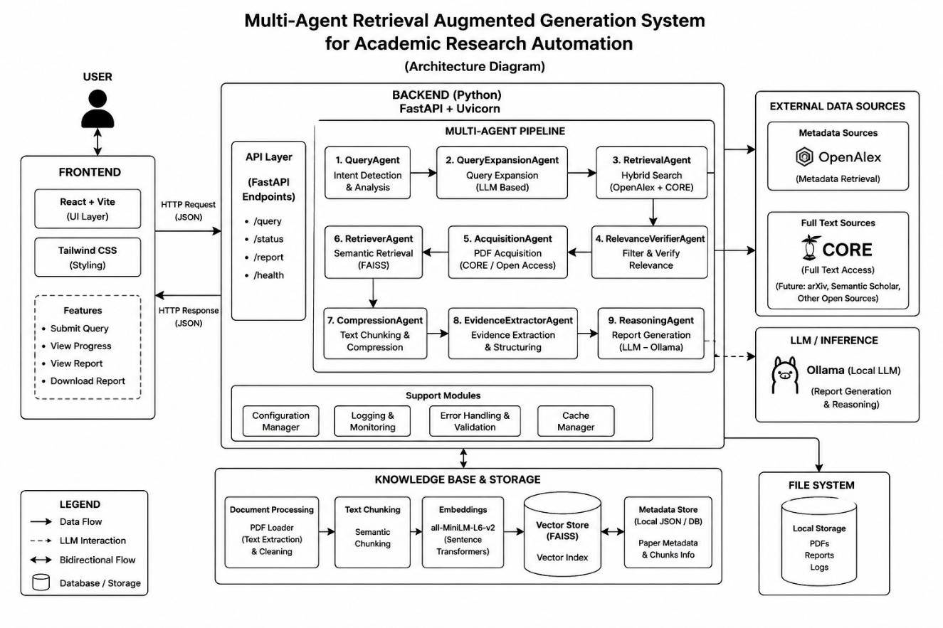
System design describes the overall structure, components, and interaction flow of the proposed The system system. The architectural design provides a high-level view of how different modules within the application communicate and work together to process research queries and generate context-aware reports. The proposed system follows a modular and scalable architecture that integrates Large Language Models (LLMs), Retrieval-Augmented Generation (RAG), semantic search, and a nine-agent multi-agent pipeline.

Fig 4.1.1: Architecture Diagram
The system is designed using a layered client-server architecture where the frontend interface communicates with backend services through REST APIs. The frontend of the application is developed using React.js with Vite as the build tool, which provides an interactive and user-friendly environment for researchers and students. The backend is implemented using FastAPI with Uvicorn, which manages query processing, document handling, API integration, and report generation.

The proposed architecture consists of several major components including:
- User Interface Layer (React.js + Vite + Tailwind CSS)
- FastAPI HTTP Gateway Layer
- Multi-Agent Pipeline Orchestration Layer (nine sequential agents)
- Academic Retrieval Services Layer (OpenAlex, CORE, Unpaywall)
- Document Acquisition and Text Processing Layer (PyMuPDF)
- Vector Embedding and FAISS Index Layer (sentence-transformers)
- LLM Inference Layer (Ollama with qwen2.5:7b)
The central architectural element is the shared ResearchState Python dataclass that flows through all nine agents. Each agent enriches or reduces the state without needing direct inter-agent communication channels. The state carries query metadata, paper metadata, document chunks, retrieval metrics, evidence objects, and the final generated answer. Errors encountered at any agent are appended to a list in the state rather than raised as exceptions, enabling the pipeline to continue with partial results when non-critical stages fail.

Table 4.1: Agent Responsibilities in Multi-Agent Pipeline
Agent | Responsibility | Key Output to State
QueryAgent | Detect query type (comparative/factual/survey/definition) and extract focus entities. | state.query_intent, state.focus_terms
QueryExpansionAgent | Generate semantically related search terms and normalized entity variants. | state.expanded_queries
RetrievalAgent | Fetch candidate papers from OpenAlex and CORE; deduplicate and score. | state.papers, state.metadata_store
RelevanceVerifierAgent | Filter weakly relevant papers using semantic overlap scoring. | state.papers (filtered)
AcquisitionAgent | Download PDFs from arXiv, OpenAlex OA URLs, Unpaywall; extract full text. | state.documents
RetrieverAgent | Build FAISS index; perform broad + focus-aware retrieval; apply CrossEncoder reranking. | state.retrieved_chunks
CompressionAgent | Compress and deduplicate retrieved chunks to reduce prompt token length. | state.retrieved_chunks (compressed)
EvidenceExtractorAgent | Build structured EvidenceObject instances from compressed chunks. | state.evidence_objects
ReasoningAgent | Generate final report using Ollama LLM; normalize citations; append references. | state.generated_answer, state.references

4.2 Context Diagram
A context diagram provides a high-level representation of the interaction between the proposed The system system and external entities such as users, academic APIs, the local LLM service, and the file system. It illustrates the flow of information into and out of the system without showing internal processing details.
In the proposed system, the primary external entities are:
- Researcher / User – submits natural language queries and receives research reports
- Academic APIs (OpenAlex, CORE, Unpaywall) – provide scholarly paper metadata and PDFs
- Local Ollama LLM Service – provides language model inference for report synthesis
- Local File System – stores downloaded PDFs and persisted FAISS index files
The researcher interacts with the system by submitting research queries through the FastAPI endpoint or React frontend and receiving generated reports with citations. The system communicates with academic APIs for paper retrieval, downloads PDFs to the local file system, builds FAISS indices from extracted text, and calls the Ollama LLM for report synthesis.

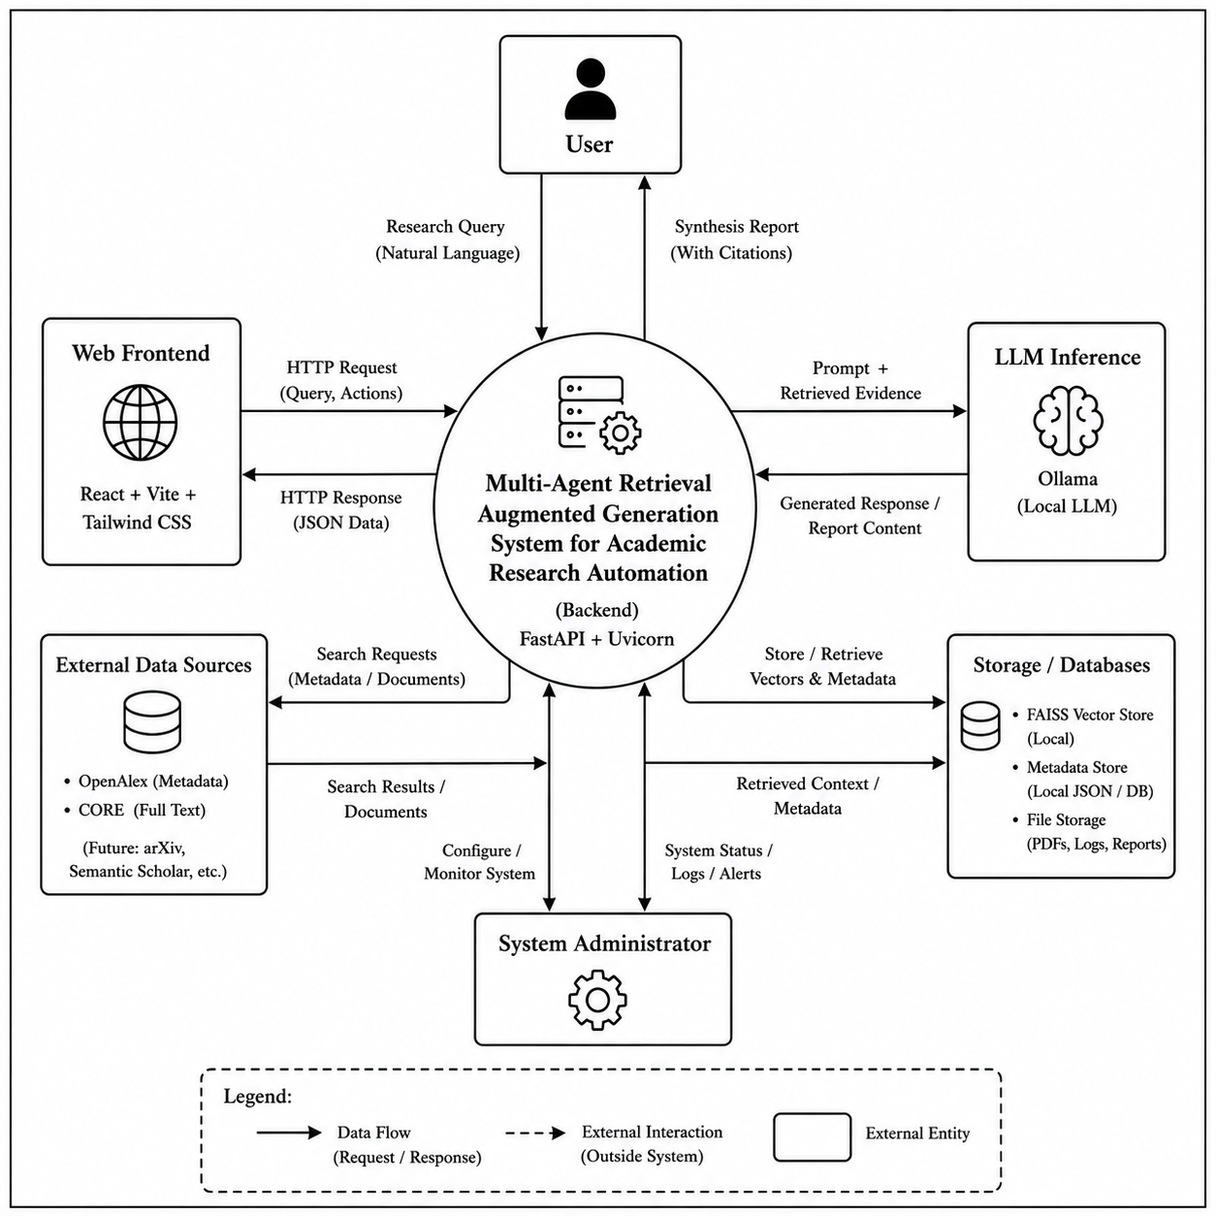
Fig 4.2.1: Context Diagram
The context diagram helps in understanding the overall communication flow and system boundaries of the proposed application. It provides a simplified overview of how different external entities interact with the The system system and contribute to information exchange within the pipeline.

CHAPTER 5
DETAILED DESIGN

5.1 System Design
The detailed design phase describes the internal structure, behavior, and interaction of various modules within the proposed The system system. The system is designed using an object-oriented approach to improve modularity, maintainability, scalability, and efficient interaction among system components. The proposed The system system integrates Retrieval-Augmented Generation (RAG), semantic search, and a nine-agent multi-agent architecture to provide context-aware automated research assistance.
The detailed design includes UML diagrams and data flow representations that illustrate system functionality, communication flow, and data model interactions. These diagrams help in understanding the architecture and operational behavior of the system during implementation and execution.
The following design diagrams are included in this chapter:
- Class Diagram
- Use Case Diagram
- Activity Diagram
- Sequence Diagram
- Data Flow Diagrams (Level 0, Level 1, and Level 2)
- Database Design (ER Diagram)
These diagrams collectively represent the structural and behavioral aspects of the proposed system.
Class Diagram
The class diagram shown below Figure 5.1.1 represents the object-oriented structure of the proposed The system system. It illustrates the major classes used in the application along with their attributes, methods, and relationships. The diagram helps in understanding how different modules within the system interact with each other to perform various operations related to query processing, document management, semantic retrieval, evidence extraction, and report generation.

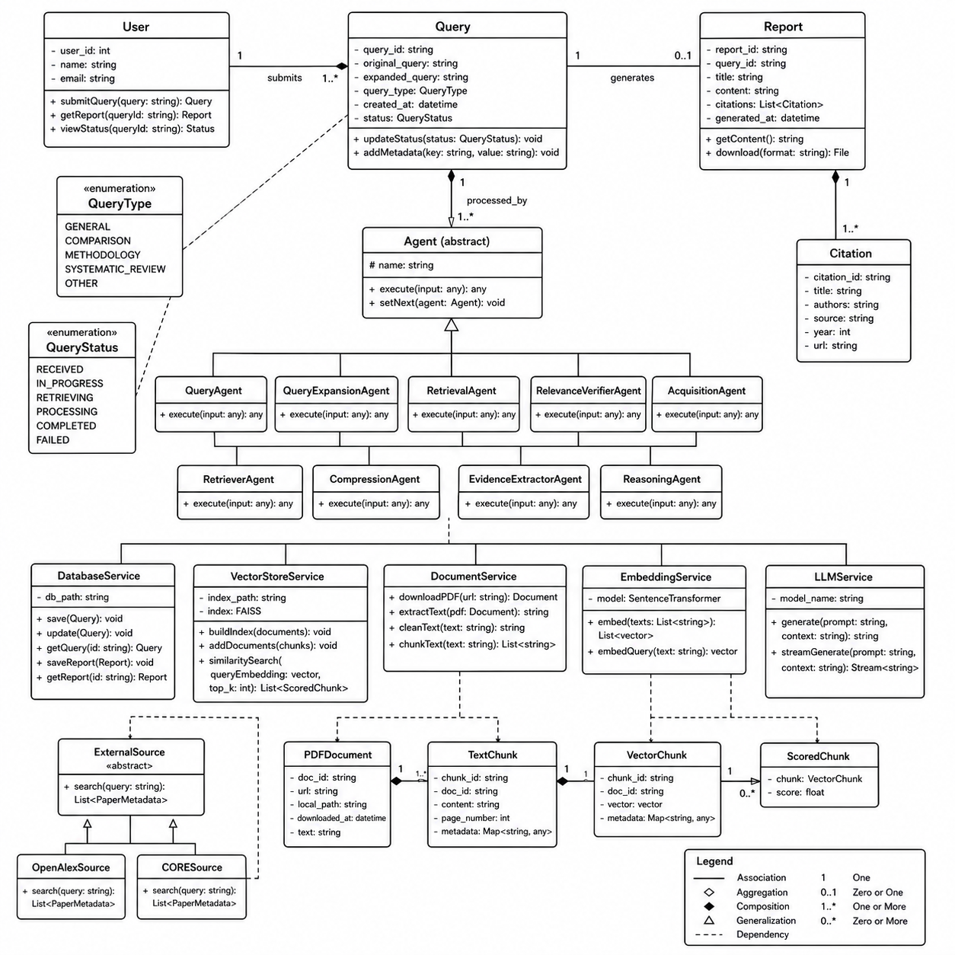
Fig 5.1.1: Class Diagram
The ResearchState dataclass is the central shared data object that flows through all nine agents. BaseAgent is the abstract superclass from which all nine concrete agent classes inherit, providing execute(), which wraps each agent's run() method with logging, timing, and error capture. The EvidenceObject class encapsulates a structured evidence item containing a claim, source paper ID, excerpt, and confidence score.
Service classes include OpenAlexClient, CoreClient, HybridRetrieval, PdfDownloader, PdfExtractor, TextProcessor, VectorStoreBuilder, Retriever, LLMService, RetrievalCache, and RateLimitManager. These are instantiated as needed within agent implementations and do not maintain cross-request state beyond what is necessary for session-level caching.

Use Case Diagram
Figure 5.1.2 illustrates the Use Case Diagram of the proposed The system System. The diagram represents the interaction between external actors and the functionalities provided by the research pipeline. It provides a high-level view of how users interact with the system to perform different operations.

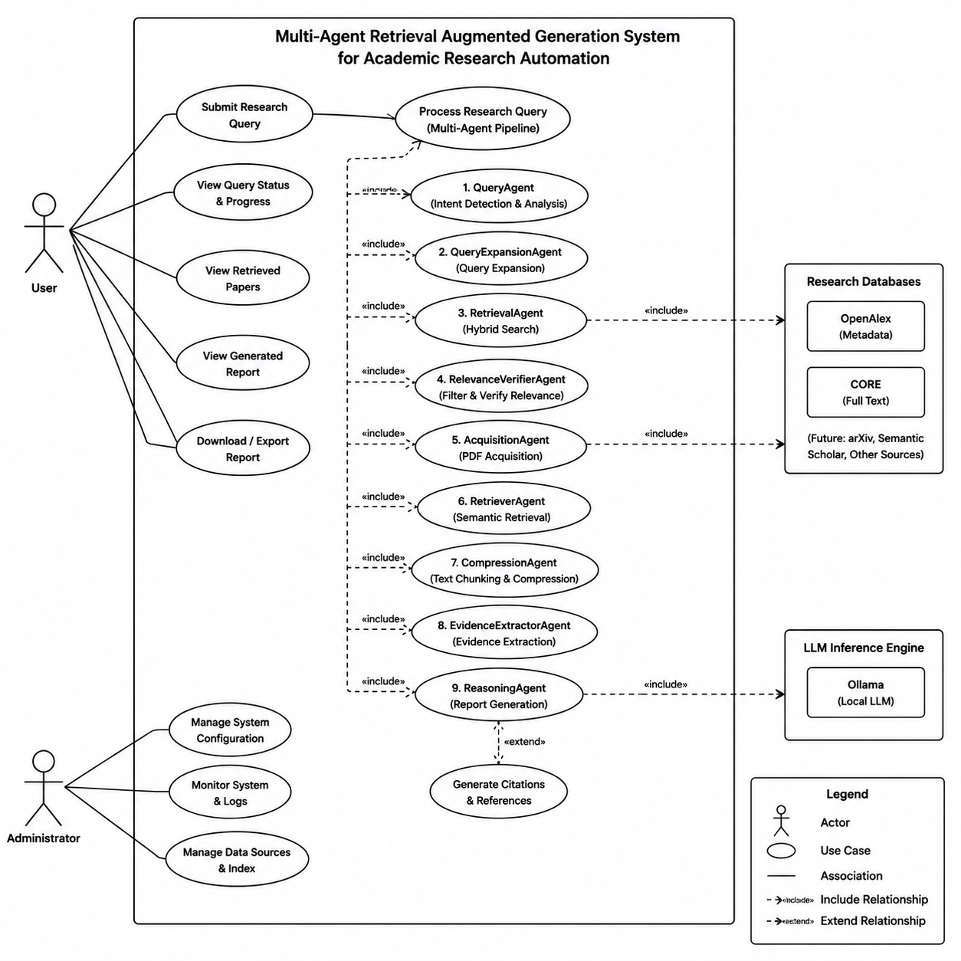
Fig 5.1.2: Use Case Diagram
The system consists of one primary actor, the Researcher (end user), who interacts with the system through either the React frontend or the FastAPI endpoint. The researcher's primary use cases are: Submit Research Query, View Generated Report, View Reference List, and View Pipeline Errors. Secondary actors are the external Academic API Services (OpenAlex, CORE, Unpaywall) and the Local Ollama LLM Service, which the system automatically invokes as part of executing the researcher's use cases.
Activity Diagram
The activity diagram represents the workflow and sequence of activities involved in query processing and report generation within the The system system.
The process begins when the researcher submits a natural language query to the system. The query undergoes intent detection and expansion. Papers are then retrieved from academic APIs, filtered for relevance, and PDFs are acquired and processed. Document chunks are embedded and indexed in FAISS. Relevant chunks are retrieved, compressed, and structured into evidence objects. When a user submits a query, the system processes the request, retrieves relevant contextual information using semantic search, and generates a final report using the Large Language Model.
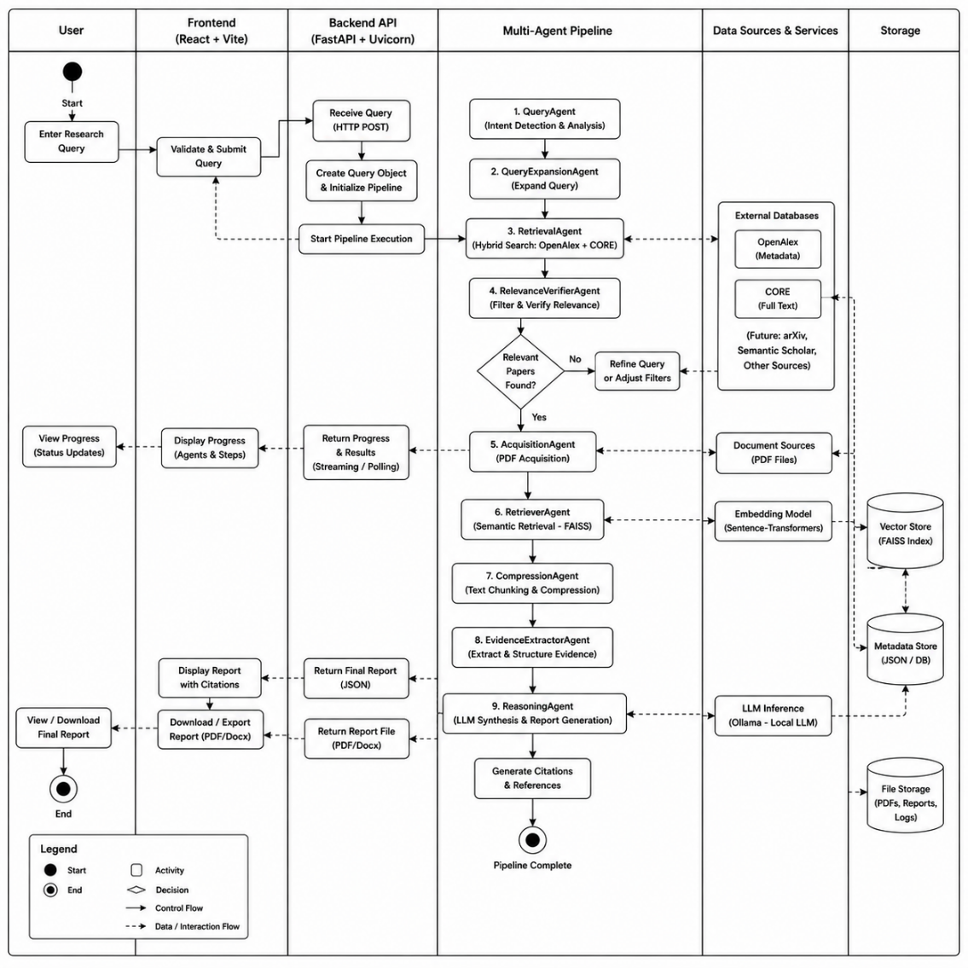
The activity diagram shows the flow of the program from the researcher's perspective:
Fig 5.1.3: Activity Diagram
Figure 5.1.3 illustrates the Activity Diagram of the proposed The system System. The diagram represents the overall workflow and sequence of activities performed within the system for a complete research query execution. It provides a clear understanding of how the system processes queries, retrieves evidence, and generates reports.
The workflow begins when the researcher submits a query. A decision node checks whether the query was successfully classified. The system then proceeds through hybrid retrieval, relevance filtering, PDF acquisition, vector indexing, semantic retrieval, evidence extraction, and LLM-based report synthesis. If any agent fails, an error is logged in state.errors and the pipeline continues with whatever partial state is available. The final report is delivered to the researcher.
Sequence Diagram
The sequence diagram illustrates the chronological interaction between different system components during query processing.
When a researcher submits a query, the FastAPI controller calls run_pipeline(query). The Pipeline Orchestrator instantiates each agent in sequence and calls execute(). The RetrievalAgent makes HTTP requests to OpenAlex and CORE APIs. The AcquisitionAgent downloads PDFs and calls PyMuPDF for text extraction. The RetrieverAgent builds the FAISS index and calls HuggingFace embeddings. The ReasoningAgent calls the local Ollama endpoint and receives the generated report. The final response is returned to the researcher through the FastAPI response.
The sequence diagram helps in understanding the communication sequence and message flow among system components.
Figure 5.1.4 illustrates the Sequence Diagram of the proposed The system System. The diagram represents the step-by-step interaction between the researcher and different system components during the research query processing operation. It helps in understanding the sequence of communication and message flow within the pipeline.

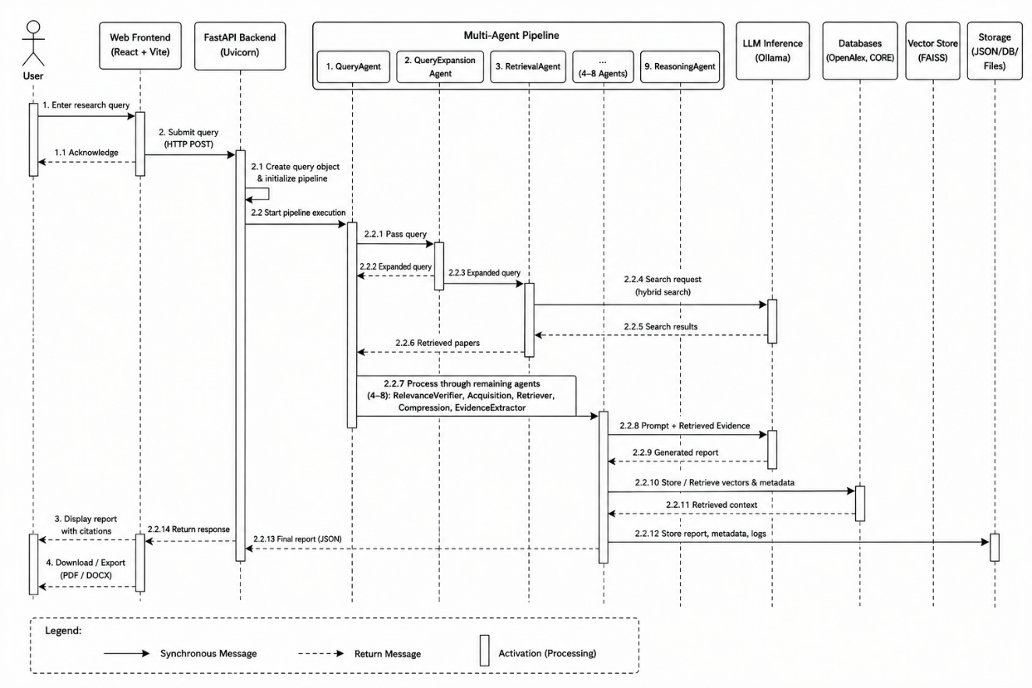
Fig 5.1.4: Sequence Diagram
Data Flow Diagrams (Level 0, Level 1, and Level 2)
The Data Flow Diagrams (DFDs) represent the movement of data within the The system system. The DFDs describe how information is processed, stored, and transferred between different entities and modules.
DFD Level 0
The Level 0 DFD provides a high-level overview of the The system system and external entities such as the Researcher, Academic APIs (OpenAlex, CORE, Unpaywall), Local Ollama LLM Service, and the Local File System (PDFs, FAISS index).
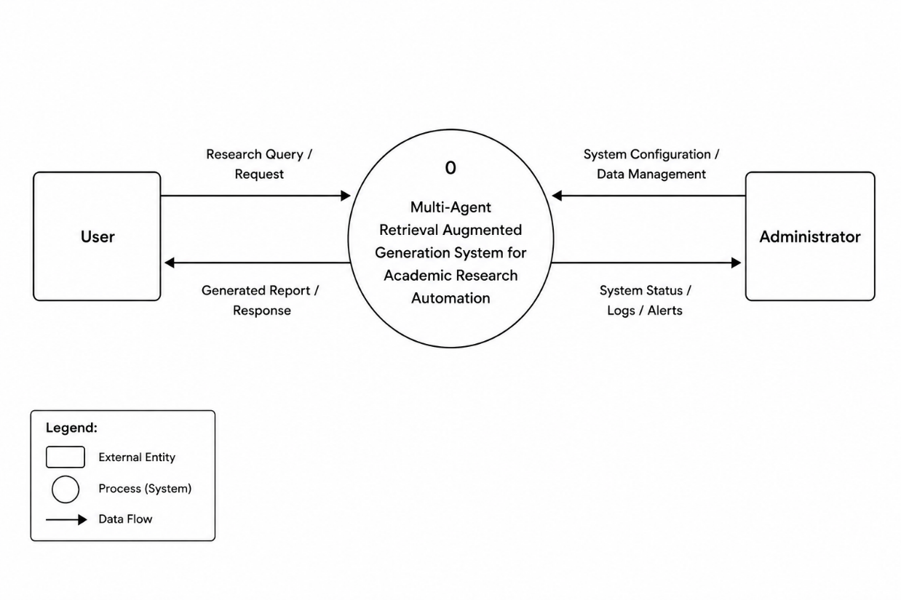
Fig 5.1.5: DFD Level 0
Figure 5.1.5 illustrates the DFD Level 0 of the proposed The system System. The central process is the The system System, which receives a Research Query from the Researcher and produces a Research Report with Citations. The system interacts with Academic APIs for paper retrieval, the Local File System for PDF and index storage, and the Local Ollama LLM for synthesis.
DFD Level 1
The Level 1 DFD illustrates major internal processes including query analysis, hybrid retrieval, document acquisition, vector indexing, semantic retrieval, evidence extraction, and report synthesis.

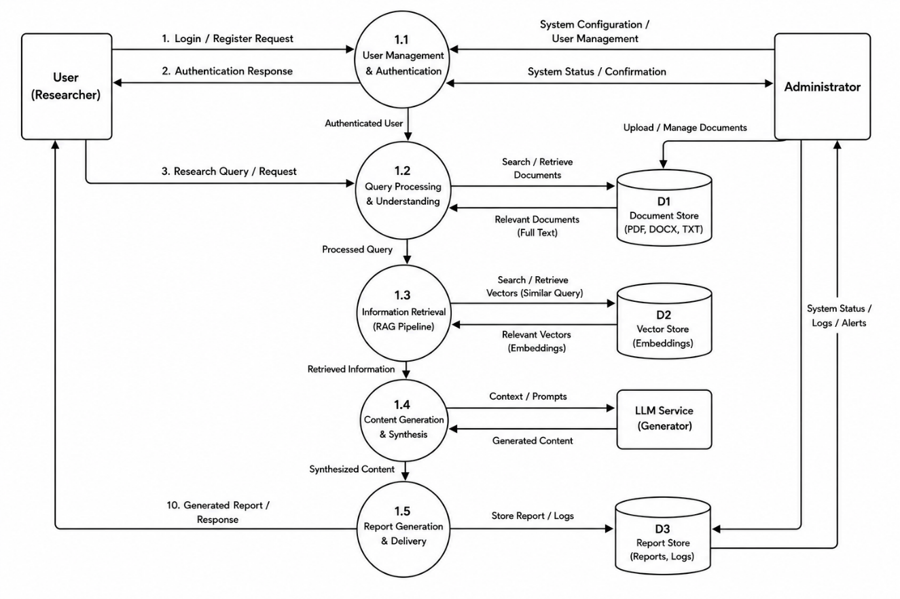
Fig 5.1.6: DFD Level 1
DFD Level 2
The Level 2 DFD provides a detailed representation of the multi-agent query processing workflow, showing how the nine agents interact with each other through the shared ResearchState object and how each agent reads from and writes to specific state fields.

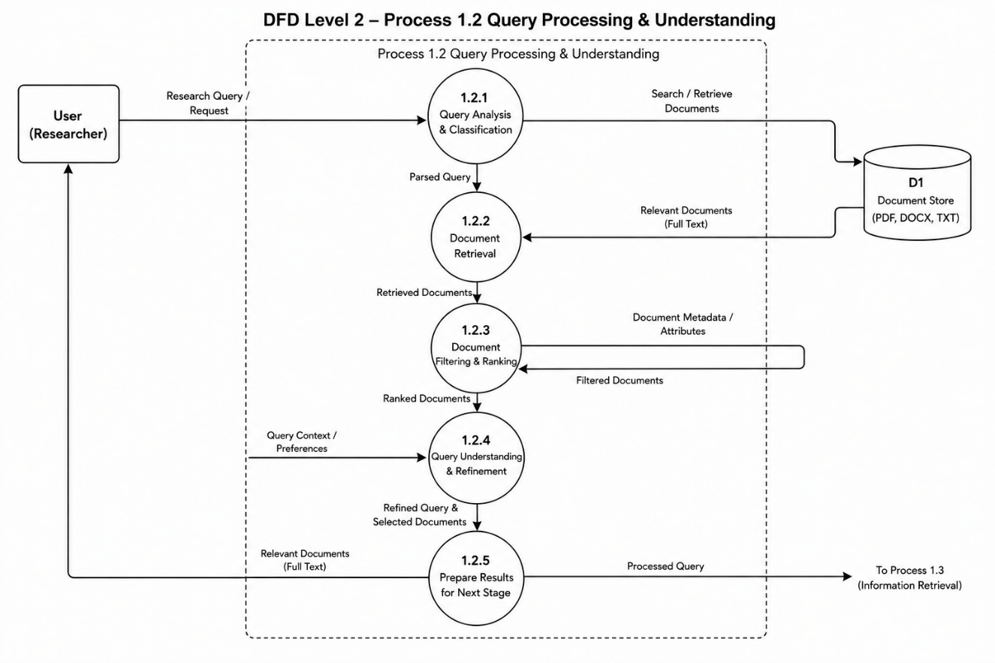
Fig 5.1.7: DFD Level 2
Figure 5.1.7 illustrates the DFD Level 2 Diagram of the proposed The system System. This diagram provides a more detailed representation of the internal workflow involved in the multi-agent query processing module. It demonstrates how individual agents transform the shared ResearchState at each stage of the pipeline.
Database Design (ER Diagram)

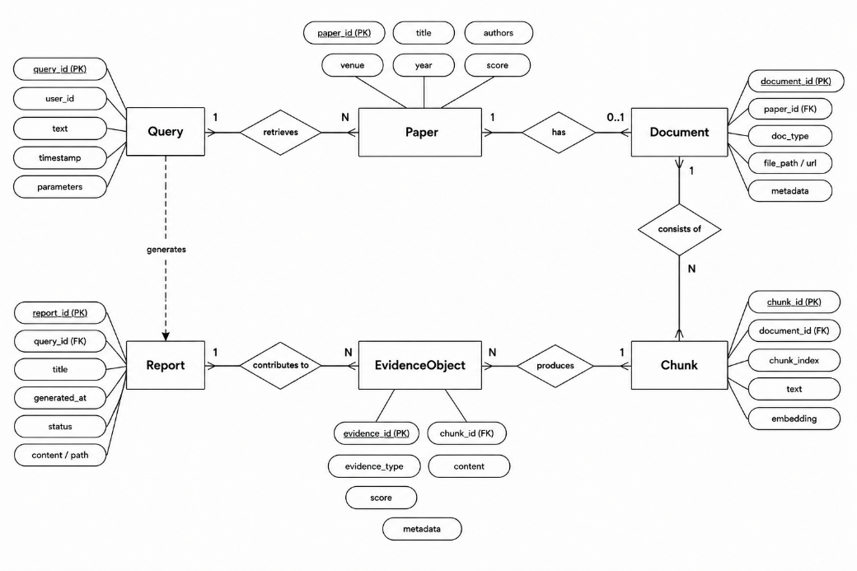
Fig 5.1.8 : ER Diagram

Figure 5.1.8 illustrates the Entity Relationship (ER) Diagram of the proposed The system System. The system does not use a relational database in its current implementation. The primary data model is the ResearchState Python dataclass, which serves as an in-memory document store for a single pipeline run. For structural documentation purposes, the ER diagram represents the logical relationships between the key data entities: Query, Paper, Document, Chunk, EvidenceObject, and Report. A Query has a one-to-many relationship with Papers; each Paper may have one Document; each Document has one-to-many Chunks; Chunks produce EvidenceObjects; and EvidenceObjects contribute to one Report.
Assumption Made
The following assumptions were considered during the design and development of the proposed The system System:
- Users have basic knowledge of academic research workflows and can formulate natural language research queries.
- A stable internet connection is available for accessing OpenAlex, CORE, and Unpaywall APIs.
- The local Ollama service is running and accessible at http://localhost:11434 during pipeline execution.
- Retrieved papers contain open-access PDFs with readable textual content for document processing.
- The CORE API key is configured in the .env file for supplementary paper retrieval.
- Administrators and developers are responsible for periodically updating model weights and API keys to maintain system accuracy.
- The system is designed for research information retrieval and does not handle sensitive personal, financial, or confidential data.
- Modern web browsers such as Google Chrome or Firefox are available for accessing the React frontend.

5.2 Detailed Design
The detailed design section describes the internal logic and operational flow of the major modules used in the proposed The system System. The system is designed using a modular approach where each agent and service performs a specific functionality related to query analysis, document retrieval, semantic search, evidence extraction, and report synthesis.
The major modules included in the system are:
- QueryAgent Module
- QueryExpansionAgent Module
- RetrievalAgent Module
- AcquisitionAgent Module
- RetrieverAgent Module
- CompressionAgent Module
- EvidenceExtractorAgent Module
- ReasoningAgent Module
- FastAPI Endpoint Module
- React Frontend Module (Planned)

5.2.1 QueryAgent Module
Purpose
The QueryAgent detects query type and extracts focus entities from the user's natural language query.
Module Logic
START
Receive natural language query from user
Apply regex-based patterns to classify query type:
IF query contains 'compare', 'versus', 'vs', 'difference' THEN
Set query_intent = COMPARISON
ELSE IF query contains 'survey', 'overview', 'review of' THEN
Set query_intent = SURVEY
ELSE IF query contains 'what is', 'define', 'explain' THEN
Set query_intent = DEFINITION
ELSE
Set query_intent = FACTUAL
Extract focus terms using noun phrase extraction
Store query_intent and focus_terms in ResearchState
END

5.2.2 RetrievalAgent Module
Purpose
The RetrievalAgent fetches candidate papers from OpenAlex and CORE APIs, deduplicates results, and scores papers by relevance.
Module Logic
START
For each expanded query string:
Query OpenAlex /works endpoint with focus terms
Query CORE search endpoint if CORE_API_KEY is present
Deduplicate results by DOI or title similarity
Score each paper: relevance_score + source_weight +
open_access_bonus + entity_coverage_score
Retain top-N papers (default N=15)
Store papers and metadata_store in ResearchState
END

5.2.3 AcquisitionAgent Module
Purpose
The AcquisitionAgent downloads PDFs and extracts full text for each retrieved paper.
Module Logic
START
For each paper in state.papers without full_text:
TRY arXiv PDF URL if arXiv ID is present
TRY OpenAlex open access URL
TRY Unpaywall API using DOI as fallback
IF PDF downloaded and valid size THEN
Extract text using PyMuPDF fitz.get_text()
Set paper.full_text = extracted_text
Add Document object to state.documents
ELSE
Use abstract if full text unavailable
END

5.2.4 RetrieverAgent Module
Purpose
The RetrieverAgent builds a FAISS vector index from document chunks and performs semantic retrieval with CrossEncoder reranking.
Module Logic
START
Split documents into chunks (size=1400, overlap=80)
Generate embeddings using all-MiniLM-L6-v2
Build FAISS index using FAISS.from_documents()
Perform broad query similarity_search(query, k)
For each focus term: perform focused similarity_search()
Merge and deduplicate all retrieved chunks
IF CrossEncoder is available THEN rerank chunks
Select final diverse set of chunks
Store retrieved_chunks in ResearchState
END

5.2.5 EvidenceExtractorAgent Module
Purpose
The EvidenceExtractorAgent processes retrieved chunks and extracts structured evidence objects with source attribution.
Module Logic
START
For each retrieved chunk:
Identify sentences with quantitative claims, methods, benchmarks
Wrap each in EvidenceObject with:
claim, source_paper_id, chunk_index, confidence_score
Store evidence_objects list in ResearchState
END

5.2.6 ReasoningAgent Module
Purpose
The ReasoningAgent generates the final research report using the Ollama LLM with structured evidence prompting.
Module Logic
START
IF query_intent == COMPARISON THEN
Build comparison-aware prompt organized by aspects:
(methods, datasets, metrics, tradeoffs, efficiency, architecture)
ELSE
Build general structured evidence prompt
Call Ollama LLM endpoint via LangChain-Ollama
Receive generated response text
Normalize inline citation markers
Append formatted references from metadata_store
Store generated_answer and references in ResearchState
END

CHAPTER 6
IMPLEMENTATION
The implementation phase represents the translation of the proposed design into a working software system. It involved building the The system automated research assistance pipeline using a combination of modern AI frameworks, semantic retrieval mechanisms, and academic data APIs [1][9]. The primary outcomes of this phase are a fully functional backend pipeline that handles query analysis, hybrid paper retrieval, document acquisition, semantic search [2][3], evidence extraction, and research report generation [6].
The system was implemented following a modular multi-agent architecture. FastAPI with Uvicorn was chosen for the backend to deliver high-performance REST API endpoints, while React.js with Vite served as the planned frontend framework responsible for user interaction. The pipeline is orchestrated through the pipeline.py module, which instantiates each of the nine agents in sequence and passes a shared ResearchState object between them [9].
The pipeline integrates Retrieval-Augmented Generation (RAG) [1] with Large Language Models [6] to improve the accuracy and contextual relevance of generated reports. Scholarly documents retrieved from OpenAlex and CORE APIs are processed through a PDF acquisition and text extraction pipeline. The resulting text segments are converted into dense vector embeddings using a Sentence Transformer model [7] and stored in the FAISS vector database [2][3] for efficient semantic similarity search during inference.
The implementation also incorporates a multi-agent architecture consisting of nine specialized agents as described in Chapter 5. The RetrievalAgent fetches papers using hybrid retrieval. The AcquisitionAgent downloads and extracts PDF text. The RetrieverAgent builds the FAISS index and retrieves evidence. The ReasoningAgent calls the local Ollama LLM. The retrieved contextual information is then used to generate citation-normalized research reports.
The implementation phase mainly focuses on:
- Query Intent Detection and Expansion
- Hybrid Academic Paper Retrieval (OpenAlex + CORE)
- PDF Acquisition and PyMuPDF Text Extraction
- Semantic Chunking and FAISS Vector Indexing
- CrossEncoder Reranking and Evidence Extraction
- LLM-based Research Report Synthesis with Citation Normalization
- FastAPI REST Endpoint for Pipeline Access
- React/Vite/Tailwind Frontend Interface (Planned)
The developed system was tested under different query scenarios to ensure proper functionality, report generation, and efficient information retrieval within the research assistance context.

6.1 Code Snippets
This section presents important code snippets used in the implementation of the proposed The system System. The snippets demonstrate key functionalities such as shared state definition, agent execution wrapper, FAISS vector store creation, hybrid retrieval scoring, FastAPI endpoint, and document chunking. The implementation was carried out using Python, FastAPI, LangChain, FAISS, Ollama, and sentence-transformers.
ResearchState Definition (state.py)
The following code snippet represents the central shared state object used across all nine agents:
@dataclass
class ResearchState:
query: str
query_intent: Optional[QueryIntent] = None
expanded_queries: List[str] = field(default_factory=list)
focus_terms: List[str] = field(default_factory=list)
papers: List[Dict] = field(default_factory=list)
metadata_store: Dict[str, PaperMetadata] = field(default_factory=dict)
documents: List[Document] = field(default_factory=list)
retrieved_chunks: List[Document] = field(default_factory=list)
evidence_objects: List[EvidenceObject] = field(default_factory=list)
generated_answer: Optional[str] = None
references: List[str] = field(default_factory=list)
errors: List[str] = field(default_factory=list)
BaseAgent Execute Wrapper (base_agent.py)
All agents inherit from BaseAgent, which provides a standardized execute() wrapper with error isolation:
class BaseAgent:
def execute(self, state: ResearchState) -> ResearchState:
start_time = time.time()
logger.info(f'Starting {self.__class__.__name__}')
try:
state = self.run(state)
except Exception as e:
error_msg = f'{self.__class__.__name__} failed: {traceback.format_exc()}'
state.errors.append(error_msg)
elapsed = time.time() - start_time
logger.info(f'{self.__class__.__name__} completed in {elapsed:.2f}s')
return state
FAISS Vector Store Creation (vector_store.py)
The following snippet generates vector embeddings and stores them in the FAISS vector database:
def create_vector_store(documents: List[Document]) -> FAISS:
embeddings = HuggingFaceEmbeddings(
model_name='sentence-transformers/all-MiniLM-L6-v2',
model_kwargs={'device': 'cpu'}
)
vector_store = FAISS.from_documents(documents, embeddings)
vector_store.save_local(FAISS_INDEX_PATH)
return vector_store
Document Processing and Chunking (text_processor.py)
The following code performs document loading and text chunking operations:
text_splitter = RecursiveCharacterTextSplitter(
chunk_size=1400,
chunk_overlap=80
)
chunks = text_splitter.split_documents(documents)
FastAPI Endpoint (app/api/routes.py)
The following snippet exposes the pipeline through a FastAPI POST endpoint:
from fastapi import FastAPI
from pydantic import BaseModel
from app.core.pipeline import run_pipeline

app = FastAPI(title='The system API')

class QueryRequest(BaseModel):
query: str

@app.post('/research')
async def research_endpoint(request: QueryRequest):
state = run_pipeline(request.query)
return {
'report': state.generated_answer or '',
'references': state.references,
'errors': state.errors
}
Hybrid Retrieval Scoring (hybrid_retrieval.py)
The following code shows the composite relevance scoring used to rank retrieved papers:
def score_paper(paper: Dict, query_terms: List[str], source: str) -> float:
score = 0.0
text = f"{paper.get('title','')} {paper.get('abstract','')}".lower()
term_hits = sum(1 for t in query_terms if t.lower() in text)
score += term_hits * 0.3
score += 0.2 if source == 'openalex' else 0.1
score += 0.15 if paper.get('open_access') else 0.0
score += 0.1 if paper.get('pdf_url') else 0.0
return score

6.2 Implementation
The implementation phase involved translating the proposed system design into a fully functional research assistance pipeline capable of handling natural language query processing, multi-source paper retrieval, document acquisition, semantic search, evidence extraction, and conversational report generation. The system was built by combining modern Python AI techniques, specifically Retrieval-Augmented Generation [1] and dense passage retrieval [8], to deliver accurate and context-aware research reports.
The frontend of the application is designed using React.js with Vite and Tailwind CSS to create a responsive and user-friendly interface for researchers. The backend was implemented using the FastAPI framework, which manages REST API communication, query processing, document handling, and interaction with external AI services.
The implemented system supports functionalities such as query intent detection, hybrid paper retrieval from OpenAlex and CORE, PDF text extraction, semantic chunking, FAISS-based vector retrieval, CrossEncoder reranking, structured evidence extraction, and LLM-based research report synthesis with citation normalization.
To improve report quality, the system uses Retrieval-Augmented Generation (RAG), where relevant contextual information is first retrieved from the FAISS vector database before generating reports using the locally hosted Ollama LLM. The system also follows a nine-agent multi-agent architecture for efficient query handling and report generation. The pipeline correctly handles both general research queries and comparison-style queries with differentiated prompt templates.
The implementation process was carried out in a modular manner, where each agent was developed and tested individually before integrating them into the complete pipeline. Screenshots of important modules and functionalities are included in the following sections to demonstrate the practical implementation and working of the proposed The system system.

6.2.1 FastAPI Backend and Pipeline Execution
The FastAPI backend was implemented to expose the The system pipeline through a REST endpoint. The pipeline.py module orchestrates the nine-agent sequential execution by instantiating agent classes in order and passing the shared ResearchState object. Each agent's execute() wrapper provides logging, timing, and error isolation so that individual agent failures do not crash the entire pipeline.

[ Attach Screenshot – Figure 6.1 : FastAPI Endpoint and Pipeline Execution ]

6.2.2 Hybrid Retrieval and FAISS Indexing
The hybrid retrieval module fetches papers from both OpenAlex and CORE APIs using expanded query terms. Retrieved papers are deduplicated by DOI or title similarity and scored using a composite formula combining relevance, source weight, open-access status, and PDF availability. The AcquisitionAgent downloads PDFs from arXiv, OpenAlex OA URLs, and Unpaywall. Extracted text is chunked using RecursiveCharacterTextSplitter (chunk_size=1400, chunk_overlap=80) and embedded using the all-MiniLM-L6-v2 model. The FAISS index is built from these embeddings and used for subsequent similarity searches.

[ Attach Screenshot – Figure 6.2 : Report Output and Citation Display ]

CHAPTER 7
SOFTWARE TESTING
Testing is one of the more important stages in building any software system. It is how one verifies that what was built actually works the way it is supposed to under normal conditions and edge cases alike. For this project, the The system pipeline was tested across all its major agent modules, starting with individual unit tests, then progressively combining modules for integration and system-level testing. Each module has its own test case numbering, and results were documented during testing to capture both passing and failing scenarios.

7.1 Test Cases
Unit Test Cases
Unit testing was performed on each agent module independently. Each module was tested in isolation to confirm it behaved correctly before being combined with others.
Module 1: QueryAgent
Type of Unit Testing: Black-box testing
TABLE 7.1.1 : QueryAgent Test Cases
Test Case ID | Test Scenario | Expected Result | Actual Result | Status | Remarks
QA-TC01 | Query: 'Compare BERT and GPT in text classification' | Type: COMPARISON; Focus: [BERT, GPT] | Type: COMPARISON; Focus: [BERT, GPT] | Passed | —
QA-TC02 | Query: 'What is transformer attention mechanism?' | Type: DEFINITION; Focus: [transformer, attention] | Type: DEFINITION; Focus: [transformer, attention] | Passed | —
QA-TC03 | Query: 'Survey of RAG applications in healthcare' | Type: SURVEY; Focus: [RAG, healthcare] | Type: SURVEY; Focus: [RAG, healthcare] | Passed | —
QA-TC04 | Query: 'How does FAISS perform on billion-scale vectors?' | Type: FACTUAL; Focus: [FAISS, billion-scale] | Type: FACTUAL; Focus: [FAISS] | Partial | Focus term extraction missed compound term; noted for improvement
Module 2: RetrievalAgent
Type of Unit Testing: Black-box testing
TABLE 7.1.2 : RetrievalAgent Test Cases
Test Case ID | Test Scenario | Expected Result | Actual Result | Status | Remarks
RT-TC01 | Query: 'Dense retrieval for NLP' | At least 5 papers from OpenAlex | 7 papers retrieved | Passed | —
RT-TC02 | Obscure query with no open access papers | state.papers may be empty; no crash | 0 papers, no crash | Passed | —
RT-TC03 | CORE API with missing key in .env | CORE skipped; OpenAlex used; error logged | Error logged; fallback used | Passed | —
RT-TC04 | Duplicate papers returned from both APIs | Deduplication retains one record per paper | Deduplication functional | Passed | —
Module 3: EvidenceExtractorAgent
Type of Unit Testing: White-box testing
TABLE 7.1.3 : EvidenceExtractorAgent Test Cases
Test Case ID | Test Scenario | Expected Result | Actual Result | Status | Remarks
EE-TC01 | Chunks containing quantitative benchmarks | EvidenceObjects with confidence > 0.5 | EvidenceObjects extracted correctly | Passed | —
EE-TC02 | Chunks with no clear claims | EvidenceObjects with lower  confidence scores | Low confidence scores assigned | Passed | —
EE-TC03 | Empty chunks list passed to agent | Empty evidence list; no crash | Empty list returned gracefully | Passed | —
Module 4: ReasoningAgent
Type of Unit Testing: Functional testing
TABLE 7.1.4 : ReasoningAgent Test Cases
Test Case ID | Test Scenario | Expected Result | Actual Result | Status | Remarks
RA-TC01 | Comparison query with structured evidence | Report with comparison sections and citations | Report with correct structure generated | Passed | —
RA-TC02 | Factual query with evidence objects | Coherent report with inline citation markers | Citations normalized and present | Passed | —
RA-TC03 | Ollama service unavailable | Error appended to state; no crash | Error logged in state.errors | Passed | —
RA-TC04 | Empty evidence objects list | Report indicates insufficient evidence | LLM reports insufficient evidence gracefully | Passed | —
Integration Test Cases
Integration testing was performed by combining related agent modules to verify that data flowed correctly between components and that inter-agent communication through ResearchState worked without errors.

TABLE 7.1.5 : Integration Test Cases
Test Case ID | Modules Combined | Test Scenario | Expected Result | Actual Result | Status
INT-TC01 | QueryAgent + QueryExpansionAgent | Query classified; expansion generated | Expanded queries populated correctly | Expanded queries correct | Passed
INT-TC02 | RetrievalAgent + RelevanceVerifierAgent | Papers retrieved and filtered | Relevant papers retained; weak papers removed | Filtering functional | Passed
INT-TC03 | AcquisitionAgent + RetrieverAgent | PDF extracted; FAISS index built | Chunks embedded and indexed | FAISS index built correctly | Passed
INT-TC04 | RetrieverAgent + EvidenceExtractorAgent | Retrieved chunks passed to evidence module | EvidenceObjects created with source IDs | Evidence extraction correct | Passed
INT-TC05 | EvidenceExtractorAgent + ReasoningAgent | Evidence objects used for LLM prompt | Final report generated with citations | Report generated correctly | Passed
System Test Cases
System testing combined all agent modules and evaluated The system as a complete, end-to-end pipeline under realistic research query scenarios.
TABLE 7.1.6 : System Test Cases
Test Case ID | Test Scenario | Modules Involved | Expected Result | Actual Result | Status
SYS-TC01 | User submits factual research query end-to-end | All 9 Agents | Full pipeline completes and report generated with citations | Workflow completed successfully | Passed
SYS-TC02 | User submits comparison query (BERT vs GPT) | All 9 Agents + Comparison Prompt | Comparison report with organized sections generated | Comparison report correct | Passed
SYS-TC03 | CORE API unavailable – fallback to OpenAlex only | RetrievalAgent + Error Handling | Pipeline continues with OpenAlex results; error logged | Fallback worked correctly | Passed
SYS-TC04 | All PDFs unavailable – abstract-only documents | AcquisitionAgent + RetrieverAgent | System uses abstracts; partial report generated | Abstract-based report generated | Passed

7.2 Testing and Validations
Testing and validation were carried out across three levels — unit, integration, and system — to progressively confirm that the pipeline worked correctly, from individual agent logic through to the full research report workflow. During testing, several edge cases were identified and handled, which is a normal and expected part of the development process.
Functional Testing
Each agent module was tested individually against its expected behavior. Most agents performed correctly from the start. A partial failure was identified in QueryAgent's focus term extraction for compound multi-word terms (QA-TC04), which was noted for future improvement. The ReasoningAgent demonstrated correct fallback behavior when the evidence list was empty, displaying a clear message rather than generating a hallucinated response.
Integration Testing
Once individual agents were stable, they were connected and tested together. All five integration test scenarios passed successfully, including the critical path from PDF extraction through FAISS indexing to evidence extraction and final report generation. The error isolation mechanism via state.errors was confirmed to work correctly: forcing individual agent failures through environment manipulation did not crash the pipeline.
System Testing
End-to-end system testing confirmed that both general and comparison-style research queries were handled correctly. The comparison-aware prompt template produced significantly more organized reports for comparison queries compared to the general prompt. The CORE API fallback to OpenAlex-only mode was verified to work gracefully. The abstract-only fallback path for papers without downloadable PDFs also functioned as expected.
Semantic Retrieval Validation
The RAG pipeline was validated using several academic queries of varying specificity. The FAISS database consistently returned relevant document chunks, and the LLM used these effectively to generate accurate, contextually grounded reports. Citation normalization post-processing confirmed that inline citation markers in the generated reports were correctly formatted and matched the reference list entries.
Performance Observation
Throughout all testing phases, the system maintained stable operation under the sequential synchronous pipeline. No crashes or unhandled exceptions were observed during normal operation. PDF download latency from external APIs was the primary source of variable execution time. The FAISS index rebuilding step added consistent overhead per run, which is flagged as a target for optimization in future enhancements.

CHAPTER 8
CONCLUSION
The The system System was developed with the goal of making academic research assistance more efficient, accurate, and automated for researchers and students. The project centred on building an intelligent multi-agent pipeline that could genuinely interpret natural language research queries and return meaningful, evidence-grounded research reports using technologies such as Large Language Models (LLMs) [6], Retrieval-Augmented Generation (RAG) [1], semantic search [7][8], and a nine-agent multi-agent architecture [15].
Unlike traditional research tools that rely on keyword matching [23][24], the proposed system retrieves contextually relevant passages from acquired scholarly documents before generating a report [1]. This retrieval-first approach noticeably improved both the accuracy and the quality of reports delivered to researchers. Integration of the FAISS vector database [2][3] enabled efficient semantic retrieval, while the nine-agent multi-agent architecture streamlined query routing, evidence extraction, and report synthesis across the pipeline.
The developed system implements important functionalities such as query intent detection, query expansion, hybrid academic paper retrieval from OpenAlex and CORE, PDF acquisition with multi-source fallback, text extraction using PyMuPDF, document chunking with LangChain, FAISS-based vector retrieval, CrossEncoder reranking, structured evidence extraction, and LLM-driven report synthesis with citation normalization. The FastAPI backend exposes the pipeline through a REST endpoint, and a React/Vite/Tailwind frontend is designed for accessible user interaction.
During implementation and testing, the The system pipeline was evaluated across a range of research query scenarios including factual, survey, definition, and comparison query types. The results indicated that the system retrieved relevant information reliably and generated context-aware, citation-normalized reports with satisfactory accuracy. Combining Retrieval-Augmented Generation [1] with semantic similarity search [7][8] gave the pipeline a clear advantage over conventional retrieval-only approaches, enabling it to produce more meaningful and contextually reliable research reports.
The modular structure of the pipeline also makes the system easier to maintain, modify, and enhance in the future. Different agents such as QueryAgent, RetrievalAgent, AcquisitionAgent, and ReasoningAgent worked together effectively during testing and validation through the shared ResearchState mechanism.
Overall, the project met its core objectives by delivering an intelligent and extensible automated research assistance system. The system demonstrates in a concrete way how conversational AI techniques — in particular LLMs [6], transformer-based embeddings [4][5], and semantic retrieval [7][8] — can be applied in academic and enterprise research environments to improve access to scholarly evidence and make literature review processes more responsive and productive.

CHAPTER 9
FUTURE ENHANCEMENTS
The proposed System was successfully developed to provide automated academic research assistance using multi-agent AI and semantic retrieval techniques. Although the current system performs effectively for research query handling and evidence-grounded report generation, there are several areas where the system can be further improved and expanded in the future. Future enhancements can help improve the overall performance, user experience, scalability, and intelligence of the research assistance pipeline.
Asynchronous Pipeline Execution
The current pipeline is entirely synchronous, meaning each agent blocks until completion before the next begins. Converting the pipeline to use Python's asyncio with async-compatible HTTP clients (httpx) would allow parallelism in stages such as PDF downloading and multi-API retrieval, where multiple operations can be performed concurrently without sequential dependency. Estimated performance improvement: 30-50% reduction in total pipeline time for typical queries.
Incremental Vector Index Management
Currently, the FAISS index is rebuilt from scratch for every pipeline run. Implementing persistent incremental indexing — where chunks from previously processed papers are retained and new papers are added incrementally — would dramatically reduce indexing time for repeated or related queries. This requires a paper-level deduplication registry to track which documents have already been indexed.
Extended Source Coverage
Integration of additional academic sources including the arXiv API, Semantic Scholar API, and PubMed Central would significantly increase retrieval recall on specialized research queries. arXiv is particularly important for cutting-edge AI and computer science research where preprint availability precedes formal journal publication by months.
Frontend Deployment and User Session Management
Completing the React/Vite/Tailwind frontend and deploying it alongside the FastAPI backend via Docker Compose would make the system accessible to non-technical users. Session management — allowing users to save, compare, and revisit past research reports — would also add substantial practical value.
Advanced Large Language Model Integration
The current system uses the locally hosted qwen2.5:7b model via Ollama for report generation. In future development, more advanced LLMs or domain-specific fine-tuned models can be tested to improve contextual understanding, report accuracy, and citation grounding. Support for streaming token generation via Server-Sent Events (SSE) would also improve perceived responsiveness.
Real-Time API and Live Database Integration
Currently, the system retrieves information from open-access academic APIs. In future versions, the system can be integrated with institutional knowledge bases and real-time research databases to provide live updates on the latest publications, preprints, and conference proceedings in any given research area.
Production Deployment and Monitoring
Containerization using Docker, deployment via Kubernetes or Docker Compose, and integration of a logging and metrics infrastructure (Prometheus, Grafana) would prepare the system for production use. API security layers including OAuth2 authentication, rate limiting, and request validation should be added before public deployment. Adding retries and circuit breakers for external APIs would further improve reliability.
Feedback-Based Learning and Quality Improvement
The research report pipeline can be enhanced with feedback-based learning mechanisms where researcher feedback on report quality is used to improve future evidence selection and prompt generation. This would allow the system to gradually improve its report accuracy based on user interaction patterns and domain-specific requirements.

BIBLIOGRAPHY

[1] P. Lewis, E. Perez, A. Piktus, F. Petroni, V. Karpukhin, N. Goyal, H. Küttler, M. Lewis, W. Yih, T. Rocktäschel, S. Riedel, and D. Kiela, "Retrieval-Augmented Generation for Knowledge-Intensive NLP Tasks," Advances in Neural Information Processing Systems, vol. 33, pp. 9459–9474, 2020.
[2] J. Johnson, M. Douze, and H. Jégou, "Billion-Scale Similarity Search with GPUs," IEEE Transactions on Big Data, vol. 7, no. 3, pp. 535–547, 2021.
[3] M. Douze, A. Guzhva, C. Deng, J. Johnson, G. Szilvasy, P. Mazaré, M. Lomeli, L. Hosseini, and H. Jégou, "The Faiss Library," IEEE Transactions on Pattern Analysis and Machine Intelligence, vol. 46, no. 5, pp. 3159–3176, 2024.
[4] A. Vaswani, N. Shazeer, N. Parmar, J. Uszkoreit, L. Jones, A. Gomez, Ł. Kaiser, and I. Polosukhin, "Attention Is All You Need," in Proc. Advances in Neural Information Processing Systems, Long Beach, CA, USA, 2017, pp. 5998–6008.
[5] J. Devlin, M. Chang, K. Lee, and K. Toutanova, "BERT: Pre-training of Deep Bidirectional Transformers for Language Understanding," in Proc. NAACL-HLT, Minneapolis, MN, USA, 2019, pp. 4171–4186.
[6] T. Brown, B. Mann, N. Ryder, M. Subbiah, J. Kaplan, P. Dhariwal, et al., "Language Models are Few-Shot Learners," Advances in Neural Information Processing Systems, vol. 33, pp. 1877–1901, 2020.
[7] N. Reimers and I. Gurevych, "Sentence-BERT: Sentence Embeddings using Siamese BERT-Networks," in Proc. EMNLP-IJCNLP, Hong Kong, China, 2019, pp. 3982–3992.
[8] V. Karpukhin, B. Oguz, S. Min, P. Lewis, L. Wu, S. Edunov, et al., "Dense Passage Retrieval for Open-Domain Question Answering," in Proc. EMNLP, Online, 2020, pp. 6769–6781.
[9] T. Wolf, L. Debut, V. Sanh, J. Chaumond, C. Delangue, A. Moi, et al., "Transformers: State-of-the-Art Natural Language Processing," in Proc. EMNLP: System Demonstrations, Online, 2020, pp. 38–45.
[10] V. Sanh, L. Debut, J. Chaumond, and T. Wolf, "DistilBERT, a Distilled Version of BERT," in Proc. Fifth Workshop on Energy Efficient Machine Learning and Cognitive Computing, Vancouver, Canada, 2019, pp. 1–5.
[11] T. Mikolov, K. Chen, G. Corrado, and J. Dean, "Efficient Estimation of Word Representations in Vector Space," in Proc. International Conference on Learning Representations Workshop, Scottsdale, AZ, USA, 2013.
[12] J. Pennington, R. Socher, and C. Manning, "GloVe: Global Vectors for Word Representation," in Proc. EMNLP, Doha, Qatar, 2014, pp. 1532–1543.
[13] S. Hochreiter and J. Schmidhuber, "Long Short-Term Memory," Neural Computation, vol. 9, no. 8, pp. 1735–1780, 1997.
[14] I. Goodfellow, Y. Bengio, and A. Courville, Deep Learning. Cambridge, MA, USA: MIT Press, 2016.
[15] S. Russell and P. Norvig, Artificial Intelligence: A Modern Approach, 4th ed. Pearson Education, 2021.
[16] D. Jurafsky and J. Martin, Speech and Language Processing, 3rd ed. Pearson Education, 2023.
[17] C. Manning, P. Raghavan, and H. Schütze, Introduction to Information Retrieval. Cambridge, U.K.: Cambridge University Press, 2008.
[18] Y. LeCun, Y. Bengio, and G. Hinton, "Deep Learning," Nature, vol. 521, no. 7553, pp. 436–444, 2015.
[19] A. Graves, A. Mohamed, and G. Hinton, "Speech Recognition with Deep Recurrent Neural Networks," in Proc. IEEE ICASSP, Vancouver, Canada, 2013, pp. 6645–6649.
[20] R. Collobert, J. Weston, L. Bottou, M. Karlen, K. Kavukcuoglu, and P. Kuksa, "Natural Language Processing (Almost) from Scratch," Journal of Machine Learning Research, vol. 12, pp. 2493–2537, 2011.
[21] K. He, X. Zhang, S. Ren, and J. Sun, "Deep Residual Learning for Image Recognition," in Proc. IEEE CVPR, Las Vegas, NV, USA, 2016, pp. 770–778.
[22] T. Chen and C. Guestrin, "XGBoost: A Scalable Tree Boosting System," in Proc. ACM SIGKDD, San Francisco, CA, USA, 2016, pp. 785–794.
[23] G. Salton and C. Buckley, "Term-Weighting Approaches in Automatic Text Retrieval," Information Processing & Management, vol. 24, no. 5, pp. 513–523, 1988.
[24] R. Baeza-Yates and B. Ribeiro-Neto, Modern Information Retrieval. New York, NY, USA: Addison-Wesley, 2011.
[25] I. Sutskever, O. Vinyals, and Q. Le, "Sequence to Sequence Learning with Neural Networks," in Proc. Advances in Neural Information Processing Systems, Montreal, Canada, 2014, pp. 3104–3112.
[26] Z. Li, Z. Wang, W. Wang, K. Hung, H. Xie, and F. L. Wang, "Retrieval-Augmented Generation for Educational Application: A Systematic Survey," Knowledge-Based Systems, Elsevier, 2024.
[27] M. Arslan, S. Munawar, and C. Cruz, "Sustainable Digitalization of Business with Multi-Agent RAG and LLM," Sustainability, MDPI, vol. 16, 2024.
[28] N. Thakur, N. Reimers, A. Rücklé, A. Srivastava, and I. Gurevych, "BEIR: A Heterogeneous Benchmark for Zero-shot Evaluation of Information Retrieval Models," in Proc. NeurIPS Track on Datasets and Benchmarks, 2021.
[29] M. Lewis, Y. Liu, N. Goyal, M. Ghazvininejad, A. Mohamed, O. Levy, V. Stoyanov, and L. Zettlemoyer, "BART: Denoising Sequence-to-Sequence Pre-training for Natural Language Generation, Translation, and Comprehension," in Proc. 58th Annual Meeting of the ACL, 2020, pp. 7871–7880.
[30] O. Khattab and M. Zaharia, "ColBERT: Efficient and Effective Passage Search via Contextualized Late Interaction over BERT," in Proc. SIGIR, ACM, 2020, pp. 39–48.
[31] A. M. Althaf, M. A. Mohammed, M. Milanova, M. C. Cakmak, and J. Talburt, "Multi-Agent RAG Framework for Entity Resolution: Advancing Beyond Single-LLM Approaches with Specialized Agent Coordination," IEEE Access, 2024.
[32] K. Guu, K. Lee, Z. Tung, P. Pasupat, and M.-W. Chang, "REALM: Retrieval-Augmented Language Model Pre-Training," in Proc. ICML, PMLR, 2020.
[33] L. Deng, H. Hu, K. Lu, and P. He, "LLM-Augmented Multi-Agent Cooperative Framework for Medical Case Retrieval in Cardiology," Journal of Biomedical Informatics, Elsevier, 2024.
[34] Y. Hu, W. Zhang, Y. Huang, Y. Huang, X. Ma, and Z. Zhao, "TM-RAG: A Transformer-Mamba Model for Long-Text Evidence Aggregation in Retrieval-Augmented Generation," Neural Networks, Elsevier, 2024.
[35] M. A. El-Enen, S. Saad, and T. Nazmy, "A Survey on Retrieval-Augmentation Generation (RAG) Models for Healthcare Applications," Neural Computing and Applications, Springer, 2024.
[36] P. Zhao, H. Zhang, Q. Yu, Z. Wang, Y. Geng, F. Fu, L. Yang, W. Zhang, J. Jiang, and B. Cui, "Retrieval-Augmented Generation for AI-Generated Content: A Survey," ACM Computing Surveys, 2024.
[37] H. Chase, "LangChain: Building Applications with LLMs through Composability," GitHub Repository, 2022. [Online]. Available: https://github.com/langchain-ai/langchain
[38] O. Khattab, K. Santhanam, X. L. Li, D. Hall, P. Liang, C. Potts, and M. Zaharia, "Demonstrate-Search-Predict: Composing Retrieval and Language Models for Knowledge-Intensive NLP," arXiv preprint, 2022.
[39] A. Asai, Z. Wu, Y. Wang, A. Sil, and H. Hajishirzi, "Self-RAG: Learning to Retrieve, Generate, and Critique through Self-Reflection," in Proc. ICLR, 2024.
[40] W. X. Zhao, K. Zhou, J. Li, T. Tang, X. Wang, Y. Hou, Y. Min, B. Zhang, J. Zhang, Z. Dong, Y. Du, C. Yang, Y. Chen, Z. Chen, J. Jiang, R. Ren, Y. Li, X. Tang, Z. Liu, P. Liu, J.-Y. Nie, and J.-R. Wen, "A Survey of Large Language Models," ACM Computing Surveys, 2023.
[41] Z. Ji, N. Lee, R. Frieske, T. Yu, D. Su, Y. Xu, E. Ishii, Y. J. Bang, A. Madotto, and P. Fung, "Survey of Hallucination in Natural Language Generation," ACM Computing Surveys, vol. 55, no. 12, pp. 1–38, 2023.
[42] N. F. Liu, K. Lin, J. Hewitt, A. Paranjape, M. Bevilacqua, F. Petroni, and P. Liang, "Lost in the Middle: How Language Models Use Long Contexts," Transactions of the ACL, vol. 12, pp. 157–173, 2024.
[43] P. He, X. Liu, J. Gao, and W. Chen, "DeBERTa: Decoding-Enhanced BERT with Disentangled Attention," in Proc. ICLR, 2021.
[44] G. Izacard and E. Grave, "Leveraging Passage Retrieval with Generative Models for Open Domain Question Answering," in Proc. EACL, ACL, 2021, pp. 874–880.
[45] T. Kwiatkowski, J. Palomaki, O. Redfield, M. Collins, A. Parikh, C. Alberti, D. Epstein, I. Polosukhin, M. Kelcey, J. Devlin, K. Lee, K. N. Toutanova, L. Jones, M.-W. Chang, A. Dai, J. Uszkoreit, Q. Le, and S. Petrov, "Natural Questions: A Benchmark for Question Answering Research," Transactions of the ACL, vol. 7, pp. 452–466, 2019.
[46] Y. Yang, H. Jin, R. Tang, X. Han, Q. Feng, H. Jiang, S. Zhong, B. Yin, and X. Hu, "Harnessing the Power of LLMs in Practice: A Survey on ChatGPT and Beyond," ACM Transactions on Knowledge Discovery from Data, 2024.
[47] T. Schick, J. Dwivedi-Yu, R. Dessì, R. Raileanu, M. Lomeli, L. Zettlemoyer, N. Cancedda, and T. Scialom, "Toolformer: Language Models Can Teach Themselves to Use Tools," in Proc. NeurIPS, 2023.
[48] M. E. Peters, M. Neumann, M. Iyyer, M. Gardner, C. Clark, K. Lee, and L. Zettlemoyer, "Deep Contextualized Word Representations," in Proc. NAACL, ACL, 2018, pp. 2227–2237.
[49] A. Nair, J. Brixey, and H. R. Arabnia, "Automated Knowledge Synthesis from Research Papers Using Transformer-Based Models," in Proc. IEEE ICMLA, 2023, pp. 745–751.
[50] D. Edge, H. Trinh, N. Cheng, J. Bradley, A. Chao, A. Mody, S. Truitt, and J. Larson, "From Local to Global: A Graph RAG Approach to Query-Focused Summarization," arXiv preprint, Microsoft Research, 2024.

